**Task 1**

* How did you use connection pooling?

**Define the connection pooling in context.html as a resource.**

**Use the resource in different servlet file.**

**Claim the resource in web.xml.**

* File name, line numbers as in Github

**cs122b-spring18-team-59/project2/prject2-demo/WebContent/META-INF/context.xml**

**the 17th line and the 22th line**

Snapshots showing use in your code

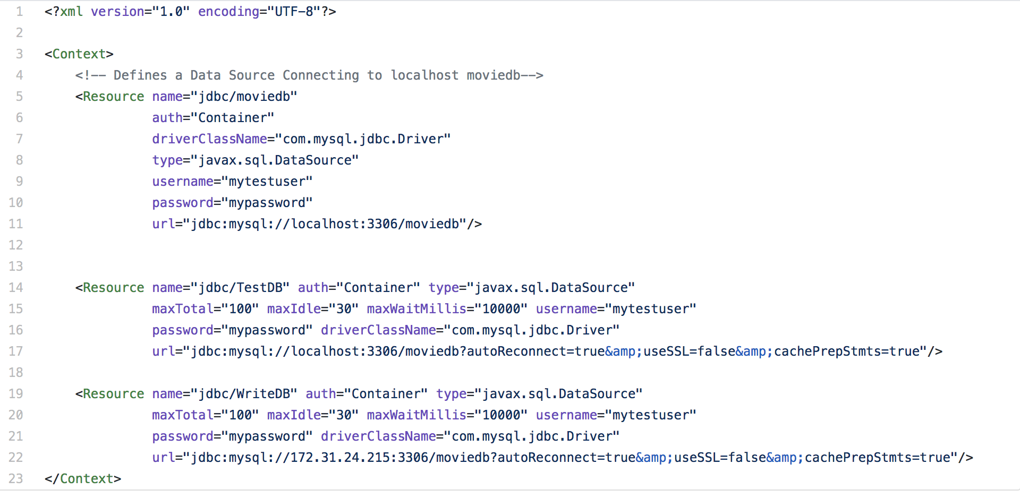

* How did you use Prepared Statements?

**First, make the string variable “query” according to the URL servlet receive, then create a prepared statement with query and send the request to MySQL database. Some prepared statement are created with query which has “?” mark so that it can be changed during the execution of the servlet.**

* File name, line numbers as in Github

[**cs122b-spring18-team-59**](https://github.com/UCI-Chenli-teaching/cs122b-spring18-team-59)**/**[**project2**](https://github.com/UCI-Chenli-teaching/cs122b-spring18-team-59/tree/master/project2)**/**[**prject2-demo**](https://github.com/UCI-Chenli-teaching/cs122b-spring18-team-59/tree/master/project2/prject2-demo)**/**[**src**](https://github.com/UCI-Chenli-teaching/cs122b-spring18-team-59/tree/master/project2/prject2-demo/src)**/MovieListServlet.java**

**196-201line**

* Snapshots showing use in your code

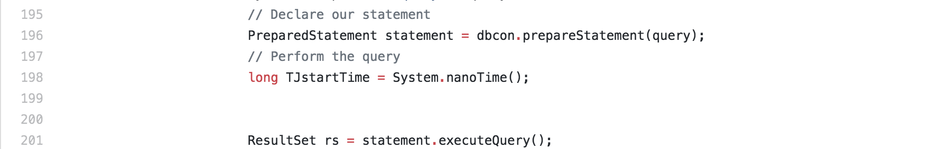

**Task 2**

* Address of AWS and Google instances

**Instance1: 13.59.66.28**

**Master: 18.219.22.240**

**Slave: 18.219.113.33**

**Google: 104.198.99.44**

* Have you verified that they are accessible? Does Fablix site get opened both on Google’s 80 port and AWS’ 8080 port?

**They are accessible. Yes, they opened the corresponding port.**

* Explain how connection pooling works with two backend SQL (in your code)?

**There are two resources in these two servers. One connects to themselves, one connects to master instance’s database. All of them use connection pooling.**

* + File name, line numbers as in Github
* **cs122b-spring18-team-59/project2/prject2-demo/WebContent/META-INF/context.xml**
* **the 17th line and the 22th line**
  + Snapshots



* How read/write requests were routed?

**Use localhost:3306 to read the database. Use master_ip:3306 to perform write.**

* + File name, line numbers as in Github

Write:

* [**cs122b-spring18-team-59**](https://github.com/UCI-Chenli-teaching/cs122b-spring18-team-59)**/**[**project2**](https://github.com/UCI-Chenli-teaching/cs122b-spring18-team-59/tree/master/project2)**/**[**prject2-demo**](https://github.com/UCI-Chenli-teaching/cs122b-spring18-team-59/tree/master/project2/prject2-demo)**/[src](https://github.com/UCI-Chenli-teaching/cs122b-spring18-team-59/tree/master/project2/prject2-demo/src)/AddMovie.java**

**93th line**

Read:

[**cs122b-spring18-team-59**](https://github.com/UCI-Chenli-teaching/cs122b-spring18-team-59)/[project2](https://github.com/UCI-Chenli-teaching/cs122b-spring18-team-59/tree/master/project2)/[prject2-demo](https://github.com/UCI-Chenli-teaching/cs122b-spring18-team-59/tree/master/project2/prject2-demo)/[src](https://github.com/UCI-Chenli-teaching/cs122b-spring18-team-59/tree/master/project2/prject2-demo/src)/**MovieListServlet.java**

**120th line**

* Snapshots

**Write:**

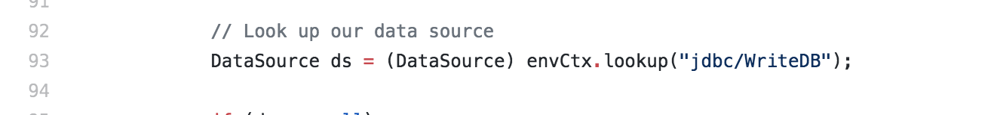

**Read:**

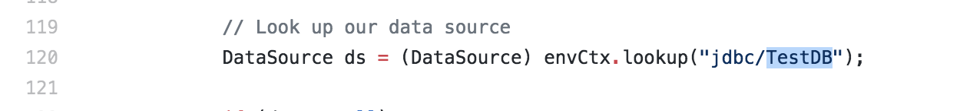

**Note: Because of sticky session, the requests sent from the same IP address to the original instance always run on the same instance, master or slave.**

**Task 3**

* Have you uploaded the log files to Github? Where is it located?

**yes**

**/cs122b-spring18-team-59/log/logfile**

* Have you uploaded the HTML file (with all sections including analysis, written up) to Github? Where is it located?
* **yes**

**/cs122b-spring18-team-59/log/jmeter_report.html**

* Have you uploaded the script to Github? Where is it located?
* **yes**

**/cs122b-spring18-team-59/project2/prject2-demo/src/Test.java**

* Have you uploaded the WAR file and README to Github? Where is it located?
* **yes**

**/cs122b-spring18-team-59/log/project2-demo.war**

**/cs122b-spring18-team-59/log/readme.txt**